Research data:

Finding homologs between sequences for chr8 700,001..795,000

Chr8 sequence Annotations

Annotation: chr8

PASTE CODING REGION HERE:



[chr8:49455025-49458016 - strand] [peptide]

IsoSeq Top Tier Results

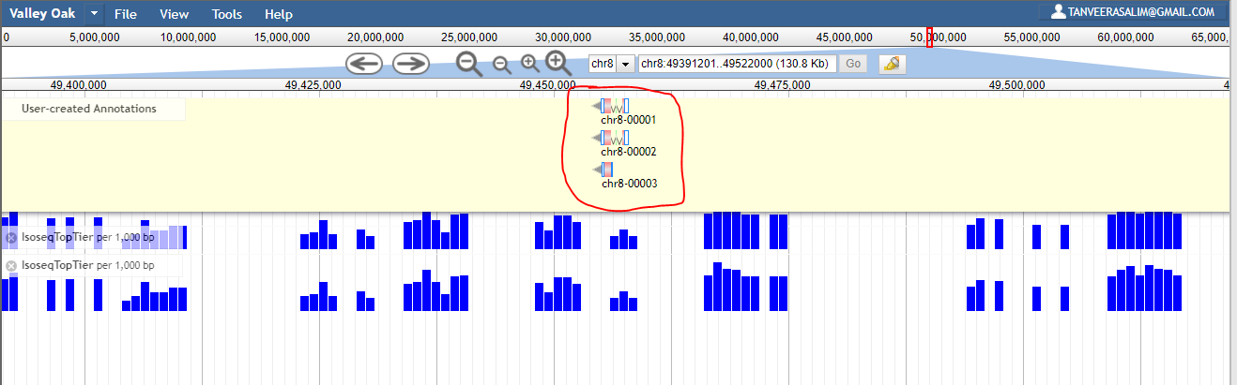

IsoSeq Top Tier Results Close-Up

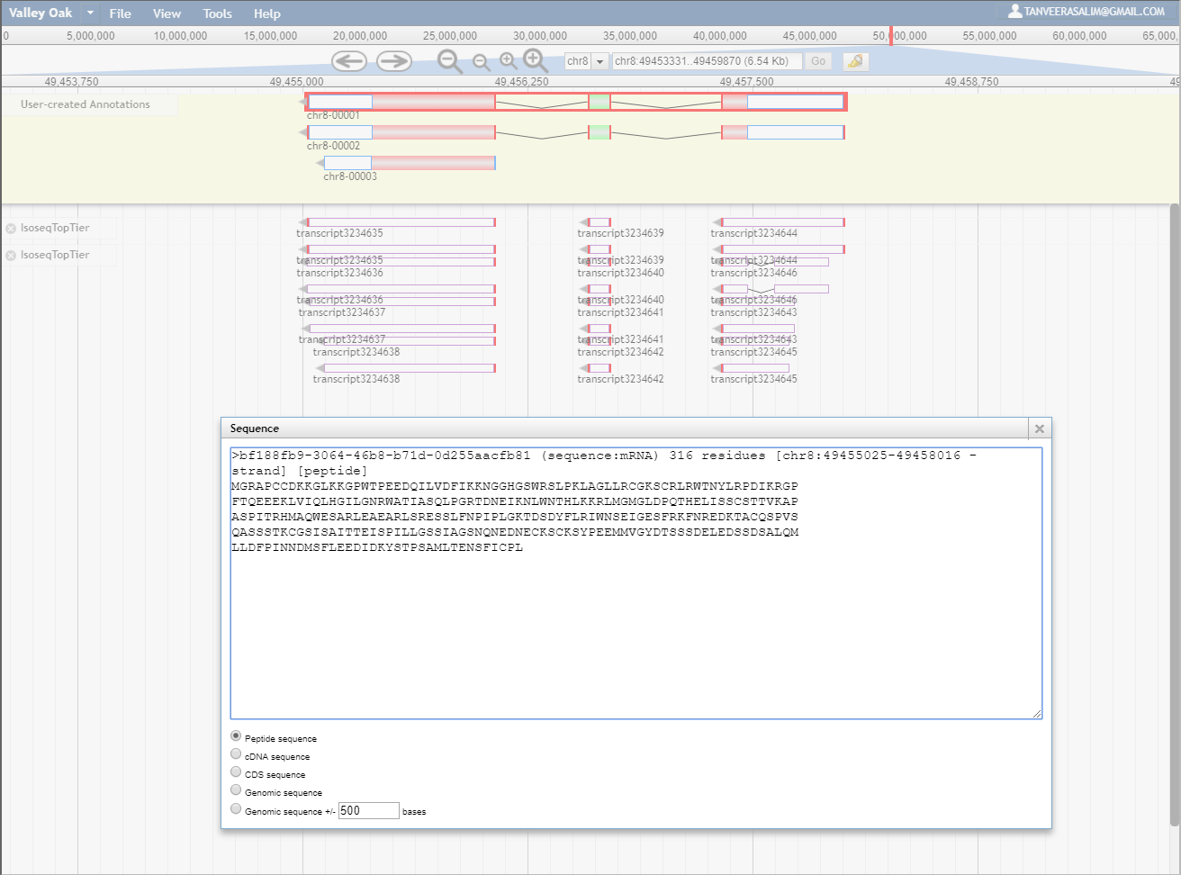

Peptide Sequences being Compared:

>bf188fb9-3064-46b8-b71d-0d255aacfb81 (sequence:mRNA) 316 residues [chr8:49455025-49458016 - strand] [peptide]

MGRAPCCDKKGLKKGPWTPEEDQILVDFIKKNGGHGSWRSLPKLAGLLRCGKSCRLRWTNYLRPDIKRGP

FTQEEEKLVIQLHGILGNRWATIASQLPGRTDNEIKNLWNTHLKKRLMGMGLDPQTHELISSCSTTVKAP

ASPITRHMAQWESARLEAEARLSRESSLFNPIPLGKTDSDYFLRIWNSEIGESFRKFNREDKTACQSPVS

QASSSTKCGSISAITTEISPILLGSSIAGSNQNEDNECKSCKSYPEEMMVGYDTSSSDELEDSSDSALQM

LLDFPINNDMSFLEEDIDKYSTPSAMLTENSFICPL

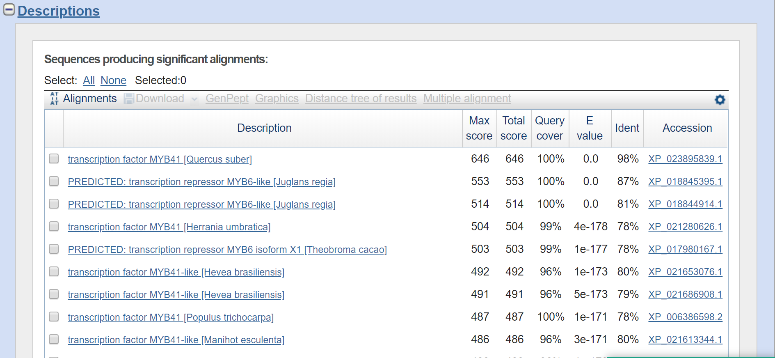

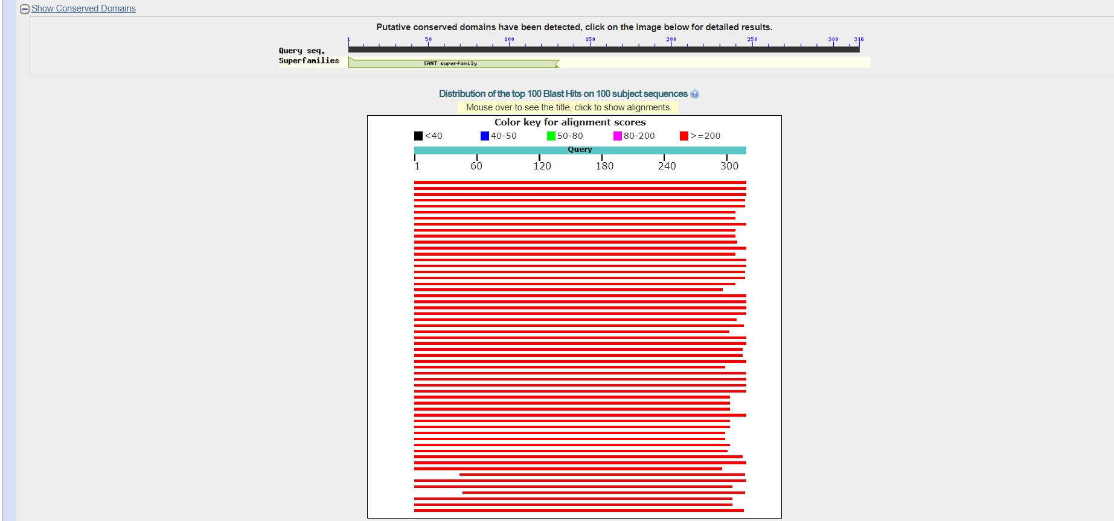

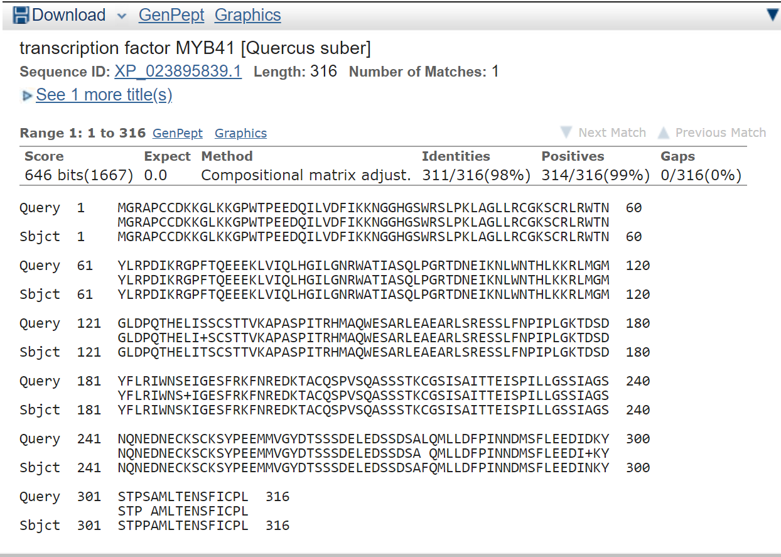

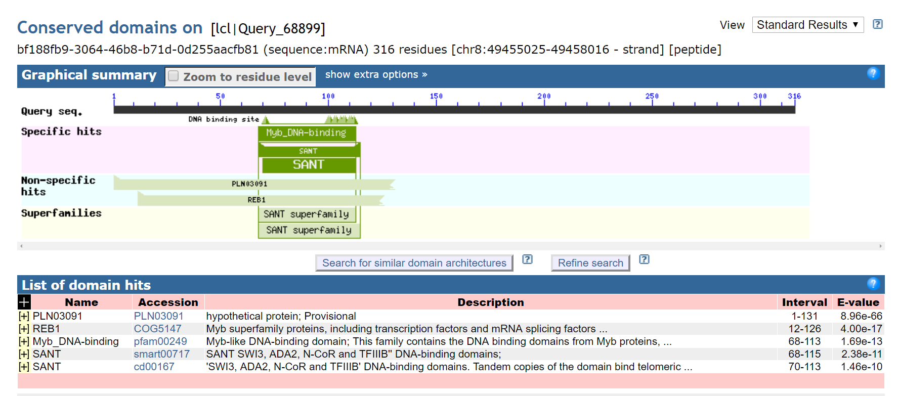

-----------------------------------------------------------------------------------------------------------------------------------

**transcription factor MYB41 [Quercus suber]**

**NCBI Reference Sequence: XP_023895839.1**

>XP_023895839.1 transcription factor MYB41 [Quercus suber]

MGRAPCCDKKGLKKGPWTPEEDQILVDFIKKNGGHGSWRSLPKLAGLLRCGKSCRLRWTNYLRPDIKRGP

FTQEEEKLVIQLHGILGNRWATIASQLPGRTDNEIKNLWNTHLKKRLMGMGLDPQTHELITSCSTTVKAP

ASPITRHMAQWESARLEAEARLSRESSLFNPIPLGKTDSDYFLRIWNSKIGESFRKFNREDKTACQSPVS

QASSSTKCGSISAITTEISPILLGSSIAGSNQNEDNECKSCKSYPEEMMVGYDTSSSDELEDSSDSAFQM

LLDFPINNDMSFLEEDINKYSTPPAMLTENSFICPL

# PREDICTED: transcription repressor MYB6-like [Juglans regia]

NCBI Reference Sequence: XP_018845395.1

>XP_018845395.1 PREDICTED: transcription repressor MYB6-like [Juglans regia]

MGRAPCCDKRGLKKGPWTPEEDEILVEYIKKNGGHGSWRSLPKLAGLLRCGKSCRLRWTNYLRPDIKRGP

FTQEEEKLVVQLHGILGNRWASIAAQLPGRTDNEIKNLWNTHLKKRLVCMGLDPQTHEPVNSCSTTIKAP

ASPTTRHMAQWESARLEAEARLSRESSLFHPNPVGGTDSDYFLRIWNSEVGESFRKFSMGDKTLCQSPVS

QASSSTKCGSMSAITTEICPILGGSSIAGSNQNEDTECKSCKSYTEEMMAASDCSSSDELEDSSENALQL

LLDFPINNDMSFLEEDLDMYALPPAMLTESSFICHL

# transcription factor MYB41 [Herrania umbratica]

NCBI Reference Sequence: XP_021280626.1

>XP_021280626.1 transcription factor MYB41 [Herrania umbratica]

MGRTPCCDRKGLKKGPWAPEEDEILVNYIKKHGHGSWRSLPKLAGLLRCGKSCRLRWTNYLRPDIKRGPF

TLEEEKLVIQLHGILGNRWAAIASQLPGRTDNEIKNLWNTHLKKRLVCMGLDPQTHEPFTPCGPTTAAPT

SPATRHMAQWESARLEAEARLSRESLLFSSPPLGKPDSDYFLRLWNSEVGESFRKLNREDKTACQSPISQ

ASSSTKCGSVSAVTIDICPNIAGSSTPASNQIEDTACKSFKSCTEDPVDASDSSCSNESEDSSDTALQLL

LDFPINNDMSFLENVDAYATSAAMLTDTSFISPSEGYLKA

# PREDICTED: transcription repressor MYB6 isoform X1 [Theobroma cacao]

NCBI Reference Sequence: XP_017980167.1

[GenPept](https://www.ncbi.nlm.nih.gov/protein/XP_017980167.1?report=genpept) [Identical Proteins](https://www.ncbi.nlm.nih.gov/ipg/XP_017980167.1) [Graphics](https://www.ncbi.nlm.nih.gov/protein/XP_017980167.1?report=graph)

>XP_017980167.1 PREDICTED: transcription repressor MYB6 isoform X1 [Theobroma cacao]

MGRTPCCDRKGLKKGPWAPEEDEILVNYIKKHGHGSWRSLPKLAGLLRCGKSCRLRWTNYLRPDIKRGPF

TLEEEKLVIQLHGILGNRWAAIASQLPGRTDNEIKNLWNTHLKKRLVCMGLDPQTHEPFTPCGPTTAAPT

SPATRHMAQWESARLEAEARLSRESLLFSSPPLGKPDSDYFLRLWNSEVGESFRKLNREDKTACQSPISQ

ASSSTKCGSVSAVTIDICPNIAGSSTPASNQIEDTACKSFKSCTEDPVDASDSSCSNESEDSSDTALQLL

LDFPINNDMSFLENVDTYATSHAMLTDTSFISPSEGYLKA

# transcription factor MYB41-like [Hevea brasiliensis]

NCBI Reference Sequence: XP_021653076.1

[GenPept](https://www.ncbi.nlm.nih.gov/protein/XP_021653076.1?report=genpept) [Identical Proteins](https://www.ncbi.nlm.nih.gov/ipg/XP_021653076.1) [Graphics](https://www.ncbi.nlm.nih.gov/protein/XP_021653076.1?report=graph)

>XP_021653076.1 transcription factor MYB41-like [Hevea brasiliensis]

MGRTPCCDKKGLKKGPWTPEEDEILVRYINKNGHGSWRSLPKLAGLLRCGKSCRLRWTNYLRPDIKRGPF

TLEEEKLVIQLHGILGNRWAAIASQLPGRTDNEVKNLWNTHLKKRLLCMGLDPQTHEPFTSCGPAIKTPA

SPATRHMAQWESARLEAEARLSRESSLFNPPTPGKTDSDYFLRMWNSEVGESFRKFNRGDKTTCQSPASA

SQASSSTKCGSFSAVTADISPNLAGYSTTASNQNEDTECKSFKSYAEDVNAGSDSSSSVELEDSSDSTLQ

LLLDFPINNDMSFLEENVDSIASYSAMQ

# transcription factor MYB41 [Populus trichocarpa]

NCBI Reference Sequence: XP_006386598.2

[GenPept](https://www.ncbi.nlm.nih.gov/protein/XP_006386598.2?report=genpept) [Identical Proteins](https://www.ncbi.nlm.nih.gov/ipg/XP_006386598.2) [Graphics](https://www.ncbi.nlm.nih.gov/protein/XP_006386598.2?report=graph)

>XP_006386598.2 transcription factor MYB41 [Populus trichocarpa]

MGRTPCCDKKGLKKGPWTPEEDDLLVTYIKKNGHGSWRSLPKLAGLLRCGKSCRLRWTNYLRPDIKRGPF

TLEEEKLVIQLHGILGNRWAAIASQLPGRTDNEIKNLWNTHLKKRLLCLGLDPQTHEPFSSRGPVNKGPA

SPATRHMAQWESARLEAEQRLSRESSLFLPPMVEKIDCDHFLRIWNSEVGESFRRINMGDNKTACQSPVS

QASSSTKCGSISAITADIIPNLSRSPATASNQNEDMEWKSPKSYAEDVLAGSDSSSAELEDLTDSTLQLL

LDFPINNDMSFLDKNIDSYATSSAMLTGPSMICPL

Chr8 Phylogenetic Tree

bf188fb9-3064-46b8-b71d-0d255aacfb81

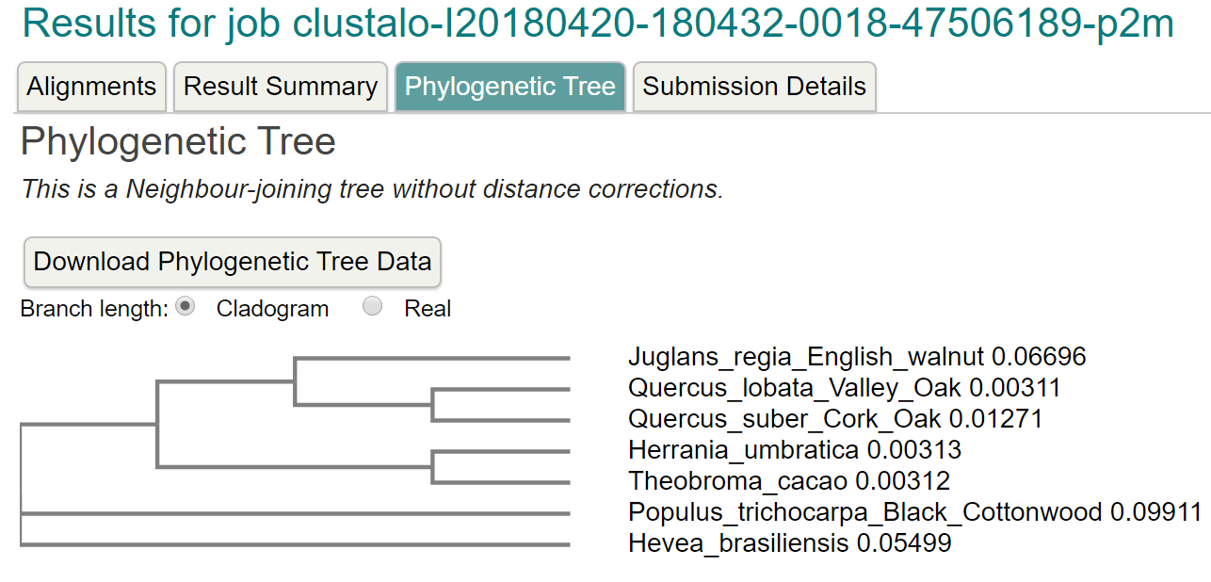

*************************************************************************************

Annotation: chr8a

Chr8a: [9262103-9267776 + strand] [peptide]

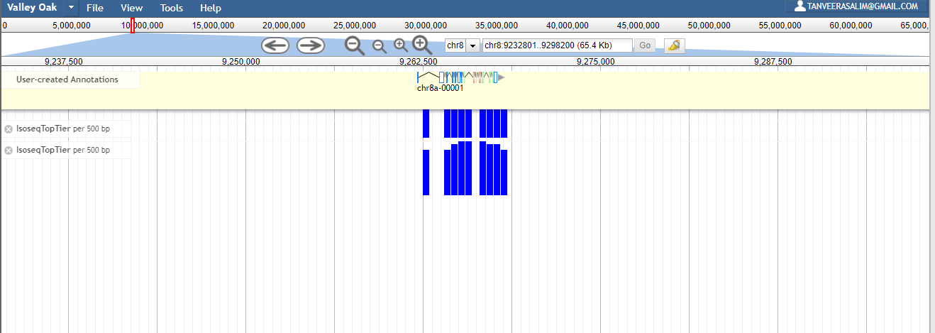

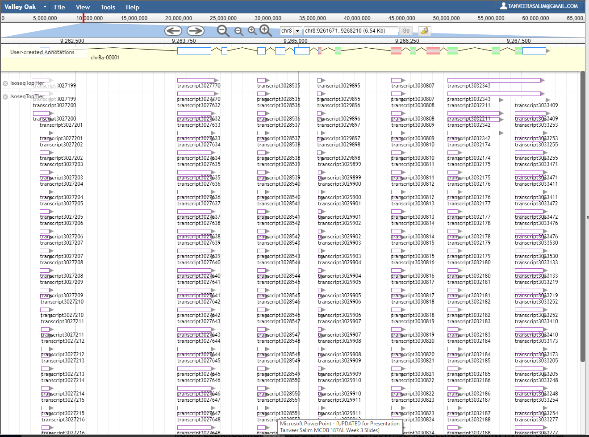

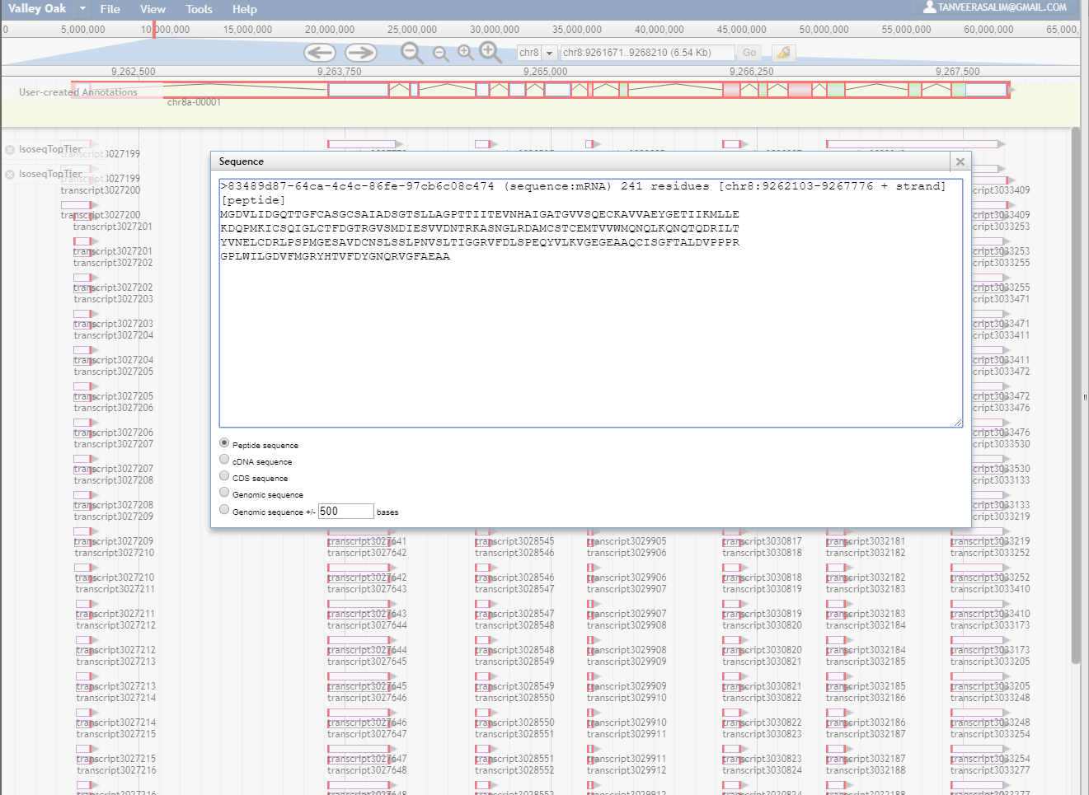

Peptide Sequences Being Compared:

>83489d87-64ca-4c4c-86fe-97cb6c08c474 (sequence:mRNA) 241 residues [chr8:9262103-9267776 + strand] [peptide]

MGDVLIDGQTTGFCASGCSAIADSGTSLLAGPTTIITEVNHAIGATGVVSQECKAVVAEYGETIIKMLLE

KDQPMKICSQIGLCTFDGTRGVSMDIESVVDNTRKASNGLRDAMCSTCEMTVVWMQNQLKQNQTQDRILT

YVNELCDRLPSPMGESAVDCNSLSSLPNVSLTIGGRVFDLSPEQYVLKVGEGEAAQCISGFTALDVPPPR

GPLWILGDVFMGRYHTVFDYGNQRVGFAEAA

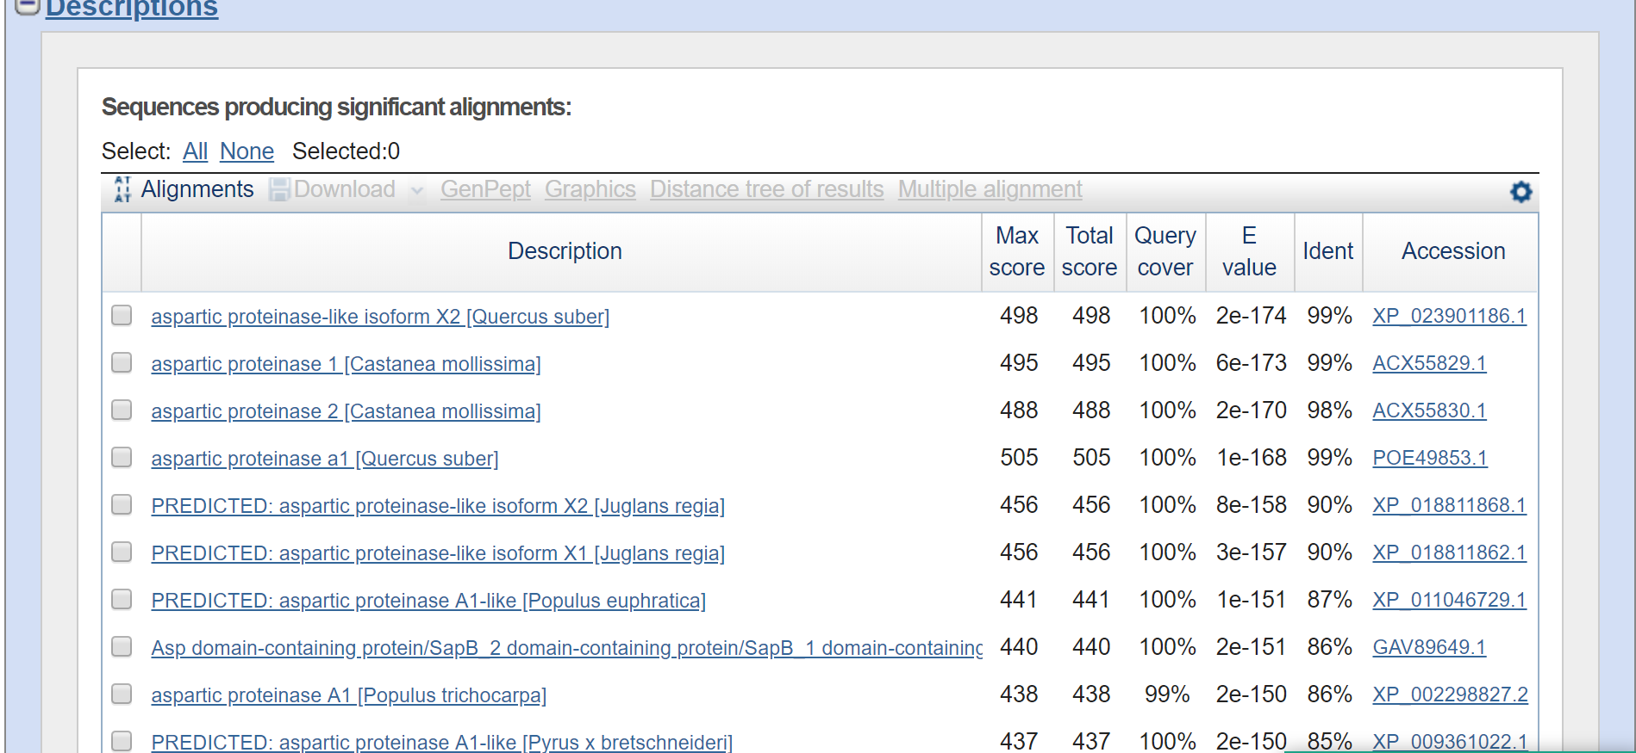

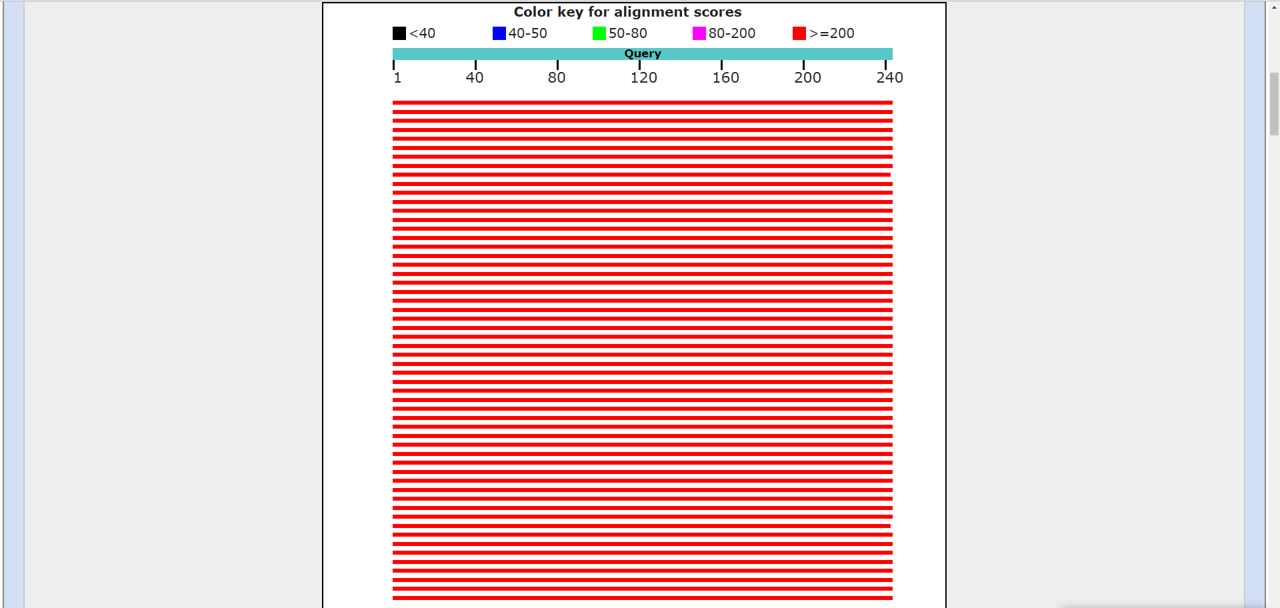



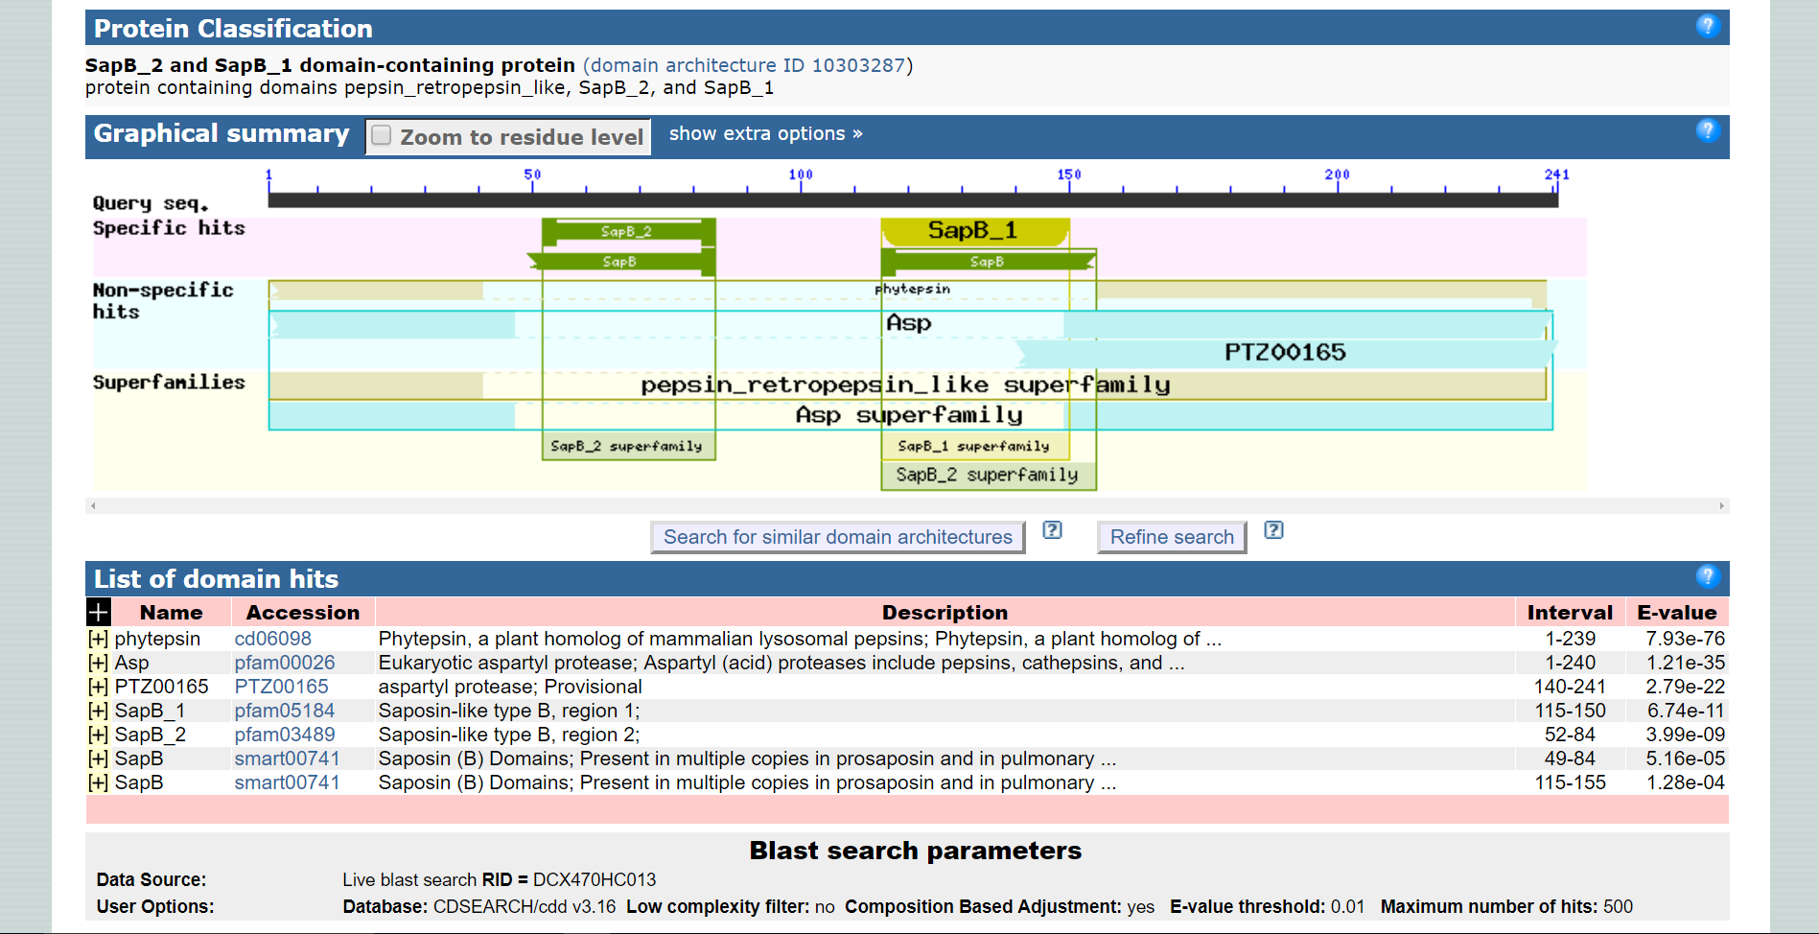

Homologous Sequences found on BLASTp

-------------------------------------------------------------------------------------------------------------------------------

1. **aspartic proteinase-like isoform X2 [Quercus suber]**

>XP_023901186.1 aspartic proteinase-like isoform X2 [Quercus suber]

MGNKLKTVVATFFLCFLLFPLVFSASNGGLVRIGLKKTKLDKNNRVAAQLESKDGEVRSASIRKYYLRGN

SGDPEDIDIVSLKNYMDAQYFGEIGVGTPPQKFTVIFDTGSSNLWVPSSKCYFSVACYFHSKYKSSSSST

YKKNGKPADIHYGTGAISGYFSQDHVKVGDLVVKNQEFIEATREPSITFLVAKFDGILGLGFKEISVGNA

VPLWYNMVKQGLVKEPVFSFWFNRNTDEEEGGEIVFGGVDPNHYKGKHTYVPVTQKGYWQFDMGDVLIDG

QTTGFCASGCSAIADSGTSLLAGPTTIITEVNHAIGATGVVSQECKAVVAEYGETIIKMLLEKDQPMKIC

SQIGLCTFDGTRGVSMDIESVVDNTRKASNGLRDAMCSTCEMTVVWMQNQLKQNQTQDRILTYVNELCDR

LPSPMGESAVDCGSLSSLPNVSLTIGGRVFDLSPEQYVLKVGEGEAAQCISGFTALDVPPPRGPLWILGD

VFMGRYHTVFDYGNQRVGFAEAA

-------------------------------------------------------------------------------------------------------------------------------

# 2. aspartic proteinase 1 [Castanea mollissima]

GenBank: ACX55829.1

[GenPept](https://www.ncbi.nlm.nih.gov/protein/ACX55829.1?report=genpept) [Identical Proteins](https://www.ncbi.nlm.nih.gov/ipg/ACX55829.1) [Graphics](https://www.ncbi.nlm.nih.gov/protein/ACX55829.1?report=graph)

>ACX55829.1 aspartic proteinase 1 [Castanea mollissima]

MGTKLKTVVATFFLCFLLFPLVFSASNGGLVRIGLKKMKLDKNNRVAAQLESKDGEVRSASIRKYYLRGN

SGDPEDIDIVSLKNYMDAQYFGEIGVGTPPQKFTVIFDTGSSNLWVPSSKCYFSVACYFHSKYKSSSSST

YKKNGKPADIHYGTGAISGYFSQDHVKVGDLVVKNQEFIEATREPSITFLVAKFDGILGLGFKEISVGNA

VPVWYNMVKQGLVKEPVFSFWFNRNTDEEEGGEIVFGGVDPNHYKGKHTYVPVTQKGYWQFDMGDVLIDG

QTTGFCARGCSAIADSGTSLLAGPTTIITEVNHAIGATGVVSQECKAVVAEYGETIIKMLLEKDQPMKIC

SQIGLCTFDGVRGVSMDIESVVDNTRKASNGLRDAMCSTCEMTVVWMQNQLKQNQTQDRILTYVNELCDR

LPSPMGESAVDCGSLSSLPNVSLTIGGRVFDLSPEQYVLKVGEGEAAQCISGFTALDVPPPRGPLWILGD

VFMGRYHTVFDYGNQRVGFAEAA

-------------------------------------------------------------------------------------------------------------------------------

# 3. PREDICTED: aspartic proteinase-like isoform X2 [Juglans regia]

NCBI Reference Sequence: XP_018811868.1

[GenPept](https://www.ncbi.nlm.nih.gov/protein/XP_018811868.1?report=genpept) [Identical Proteins](https://www.ncbi.nlm.nih.gov/ipg/XP_018811868.1) [Graphics](https://www.ncbi.nlm.nih.gov/protein/XP_018811868.1?report=graph)

>XP_018811868.1 PREDICTED: aspartic proteinase-like isoform X2 [Juglans regia]

MGTKLKPVVASFFFCLLLFPLVFSASNGGLVRVGLKKRKFDQNDRIAAQLESKEGKAWKASIRKYHLRGN

SGDPEDTDIVALKNYMDAQYFGEIGIGTPPQKFTVIFDTGSSNLWVPSSKCYFSVACYFHSKYKSSSSST

YKKNGKPADIHYGTGAISGYFSQDHVKVGDLVVEGQEFIEATREPSITFLVAKFDGILGLGFQEISVGNA

VPVWYNMVNQGLVKEPVFSFWFNRNADEEEGGEIVFGGVDPNHYKGEHTYVPVTQKGYWQFDMGDVMIDG

ETTGFCGSGCSAIADSGTSLLAGPTTIITQVNHAIGATGVVSQECKAVVAEYGETIIKMLLEKDQPQKIC

AQIGLCTFDGTRDVSIGIESVVDDDTRKASGGLRDTMCSTCEMAVVWMQNQLKQNQTQDRIINYANDLCD

RLPSPMGESAVDCASLSSMPNVSFTIGGRVFDLRPEQYVLKVGEGDAAQCISGFTALDVPPPRGPLWILG

DVFMGRYHTVFDYGNQRIGFAEAA

-------------------------------------------------------------------------------------------------------------------

# 4. PREDICTED: aspartic proteinase A1-like [Populus euphratica]

NCBI Reference Sequence: XP_011046729.1

[GenPept](https://www.ncbi.nlm.nih.gov/protein/XP_011046729.1?report=genpept) [Identical Proteins](https://www.ncbi.nlm.nih.gov/ipg/XP_011046729.1) [Graphics](https://www.ncbi.nlm.nih.gov/protein/XP_011046729.1?report=graph)

>XP_011046729.1 PREDICTED: aspartic proteinase A1-like [Populus euphratica]

MGTILKPVAAATLFLCFLLLPMISSTLSPPNDGLIRIGLKKRKYERNNRLAAKLESKEGDSIKKYHLLRN

LGGDAEDTDIVSLKNYMDAQYFGEIGIGTPPQKFTVIFDTGSSNLWVPSSKCYFSVACYFHSKYKSSHSR

TYKENGKSAEIHYGTGAISGFFSQDHVKVGDLVVKNQEFIEATREPSVTFLVAKFDGILGLGFQEISVGK

AVPVWYNMVDQGLVKEPVFSFWFNRNADEKEGGEIVFGGVDPDHYKGEHTYVPVTQKGYWQFDMGDVLIG

GQTSGFCASGCAAIADSGTSLLAGPTTIITEVNHAIGATGVVSQECKEVVAQYGDTIIEMLLAKDQPQKI

CSQIGLCTFDGTRGVSVGIESVVNEHAQKASDGFHDAMCSTCEMAVVWMQNQLKQNQTQERILDYVNELC

ERLPSPMGESAVDCDGLSSMPNVSFTIGGRVFDLSPEQYVLKVGEGDVAQCISGFTALDVPPPRGPLWIL

GDVFMGRFHTVFDYGNMRVGFAEAS

--------------------------------------------------------------------------------------------------------------------------------

# 5. aspartic proteinase A1 [Populus trichocarpa]

NCBI Reference Sequence: XP_002298827.2

[GenPept](https://www.ncbi.nlm.nih.gov/protein/XP_002298827.2?report=genpept) [Identical Proteins](https://www.ncbi.nlm.nih.gov/ipg/XP_002298827.2) [Graphics](https://www.ncbi.nlm.nih.gov/protein/XP_002298827.2?report=graph)

>XP_002298827.2 aspartic proteinase A1 [Populus trichocarpa]

MGTILKPVAAATLFLCFLLLPMISSALSPPNDGLIRIGLKKRKYERNNRLAAKLESKEGESIKKYHLLRN

LGGDAEDTDIVSLKNYMDAQYFGEIGIGTPPQKFTVIFDTGSSNLWVPSSKCYFSVACYFHSKYKSSHSR

TYKENGKSAEIHYGTGAISGFFSQDHVKVGDLVVKNQEFIEATREPSVTFLVAKFDGILGLGFQEISVGK

AVPVWYNMVEQGLVKEPVFSFWFNRNADEKEGGEIVFGGVDPDHYKGEHTYVPVTQKGYWQFDMGDVLIG

GQTSGFCASGCAAIADSGTSLLAGPTTIITEVNHAIGATGVVSQECKAVVAQYGDTIMEMLLAKDQPQKI

CAQIGLCTFDGTRGVSMGIESVVNEHAQKASDGFHDAMCSTCEMAVVWMQNQLKQNQTQERILDYVNELC

ERLPSPMGESAVDCDGLSSMPNVSFTIGGRVFELSPEQYVLKVGEGDVAQCISGFTALDVPPPRGPLWIL

GDVFMGSFHTVFDYGNMRVGFAEAT

----------------------------------------------------------------------------------------------------------------------------

# 6. PREDICTED: aspartic proteinase A1-like [Pyrus x bretschneideri]

NCBI Reference Sequence: XP_009361022.1

[GenPept](https://www.ncbi.nlm.nih.gov/protein/XP_009361022.1?report=genpept) [Identical Proteins](https://www.ncbi.nlm.nih.gov/ipg/XP_009361022.1) [Graphics](https://www.ncbi.nlm.nih.gov/protein/XP_009361022.1?report=graph)

>XP_009361022.1 PREDICTED: aspartic proteinase A1-like [Pyrus x bretschneideri]

METKLKSVTAMLFLCFLLFPLVFCESNDGLLRIGLKKRKLDQNNRVAAQIDSKEGESLRAVLQKYRLGGN

LADSQDIDIVSLKNYMDAQYFGEIGIGTPPQKFTVIFDTGSANLWVPSSKCYFSIACYLHPKYKSSSSST

YNKNGKPAAIQYGTGAISGFFSEDHVTVGDLVVKDQEFIEATKEPGVTFVVAKFDGILGLGFQEISVGNA

VPVWYNMVNQGLLKEPVFSFWFNRNADEEEGGEIVFGGVDPNHYKGEHTYVPVTQKGYWQFDMGDVMIDG

QTTGFCASGCSAIADSGTSLLVGPTTIITELNHAIGASGIVSQECKTVVAEYGETIIERILAKDQPAKIC

SQIGLCSFDGTHGVSIGIKSVVENTHKVSGDLSDATCSACEMTVVWMQNQLKQNQTQERILDYVNQLCDR

LPSPMGESAVDCAGLSSMPNVSFTIGGRTFDLTPEQYVLKVGEGDAAQCISGFTALDVPPPRGPLWILGD

VFMGRYHTVFDYGNERIGFAEAA

